

PHP PROJECT USER GUIDE

Online Movie Booking System

**(Batch: 2112F1)**

20.11.2022

**─**

|  |  |
| --- | --- |
| Student1350700 | FAIZ ULLAH KHAN |
| Student1333306 | AMAN ULLAH |
| Student1351064 | MUHAMMAD ISMAIL |
| Student1350716 | SITARA EIJAZ |

**PROJECT** **SUBMITTED BY**

**Project Instructor Miss** **Hafsa khan**

**Batch Code 2112F1**

# 

SCREEN SHOTS OF

Online Movie Booking System

# Home Page:

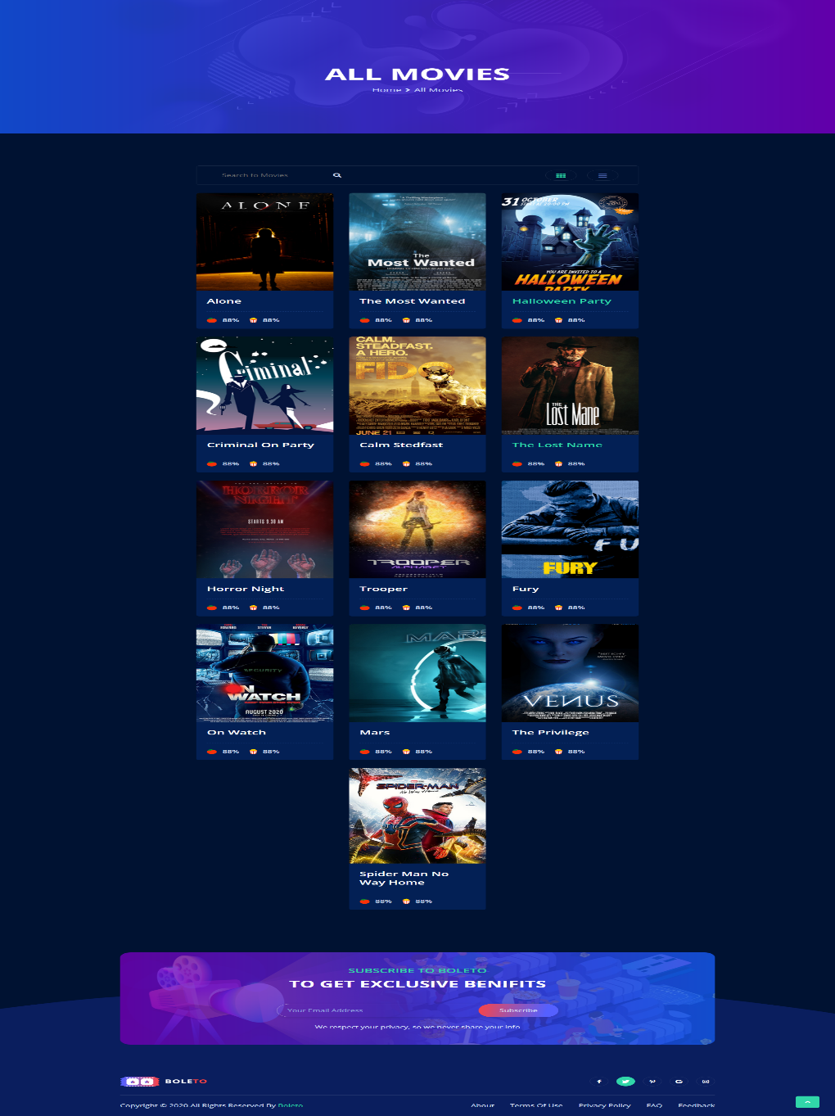

# About Page:

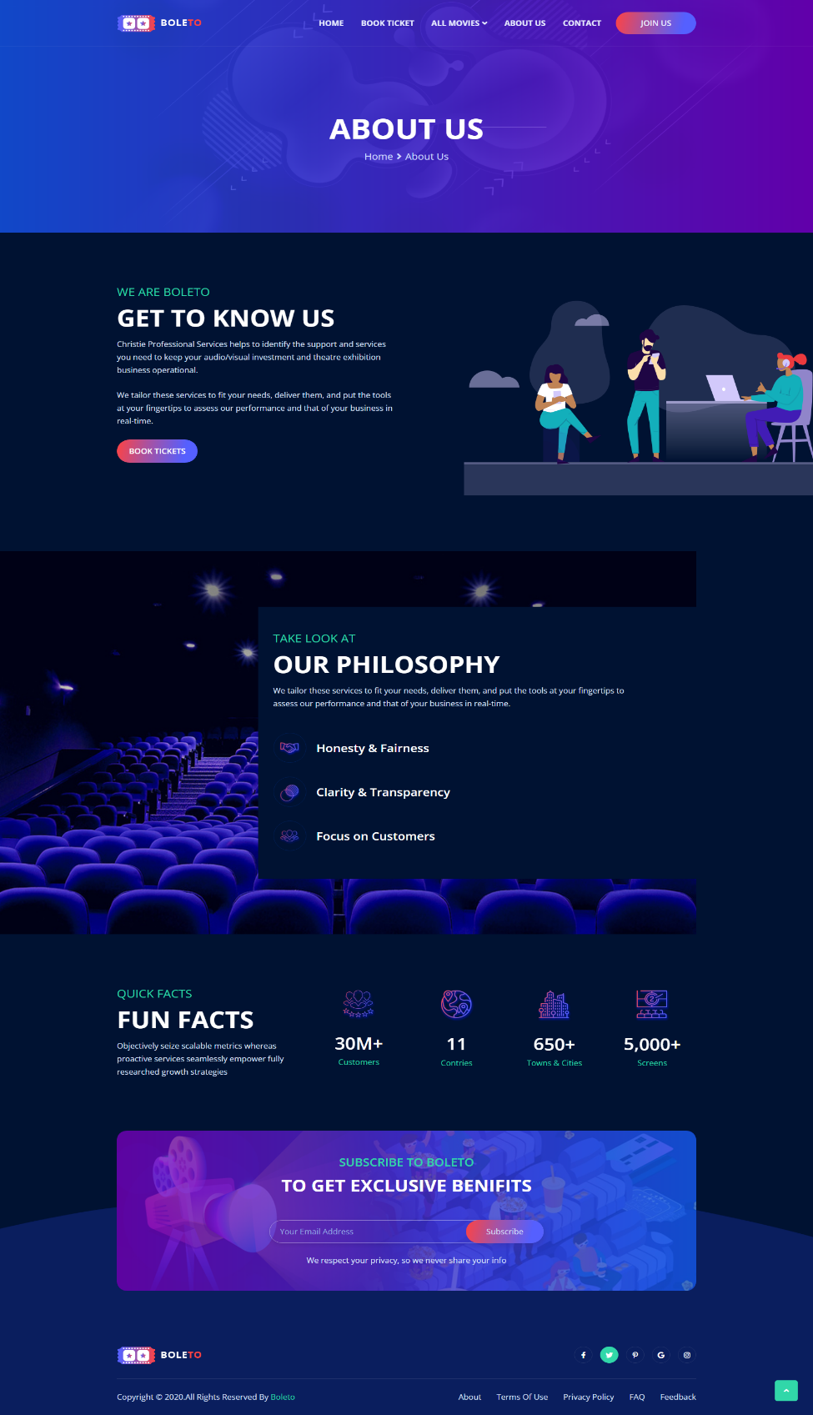

# Contact Us Page:

This Is Contact page User Can Contact Admin by Composing Mail

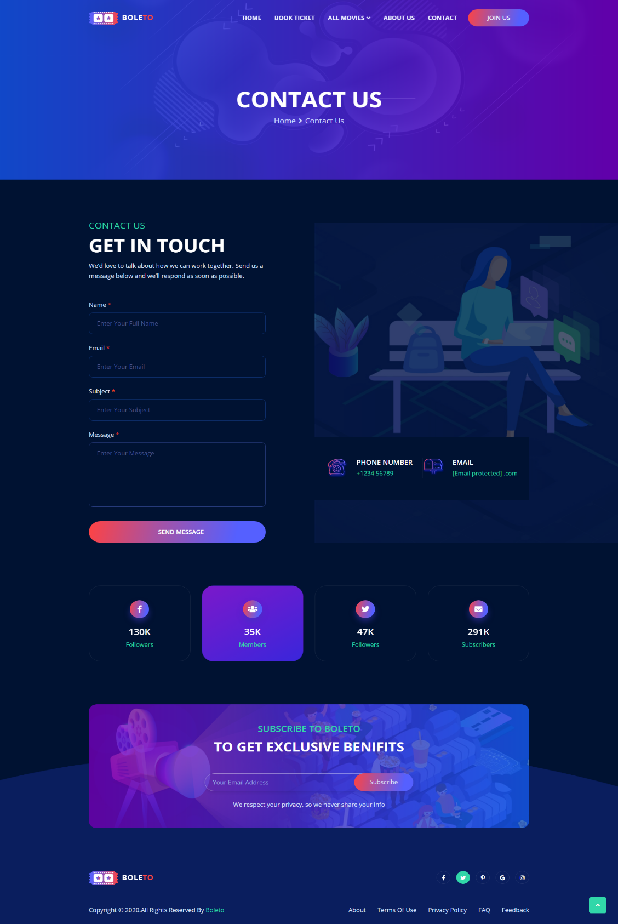

# Signup Page:

# Login Page:

# Booking Ticket:

# 

# Booking Ticket:

Database of PHP Project:

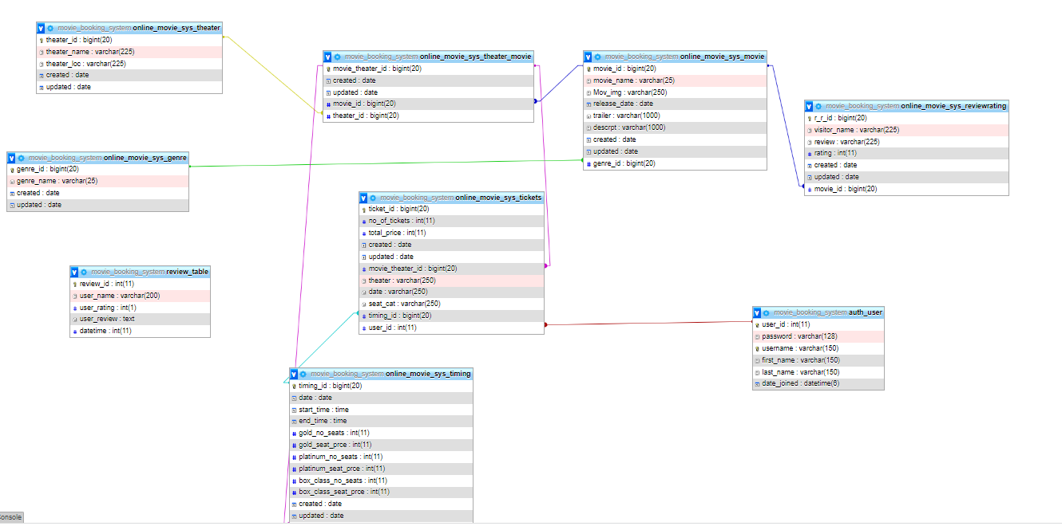

# THE END ….